RETAIL SALES DATA ANALYSIS

FULL NAME/S: ANITHA POSWAYO
STUDENT NUMBER: 2805002169

SCREENSHORTS
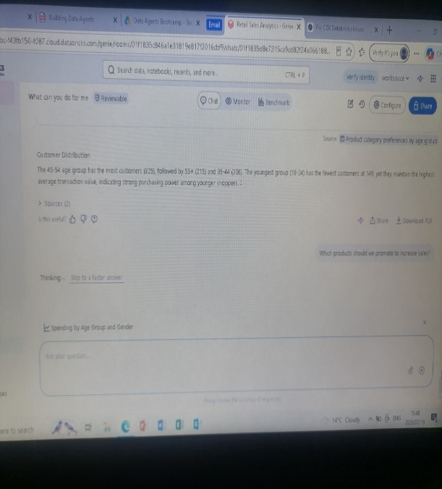


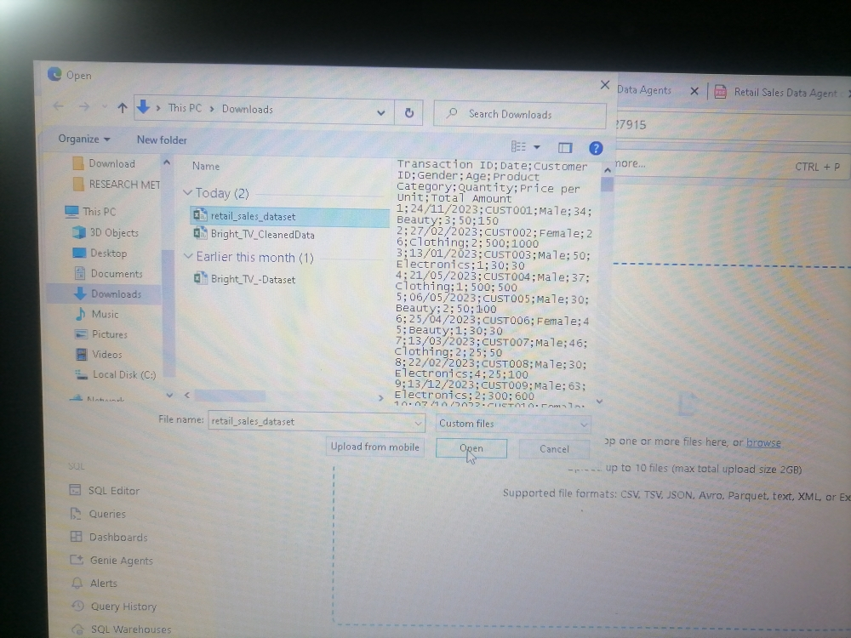

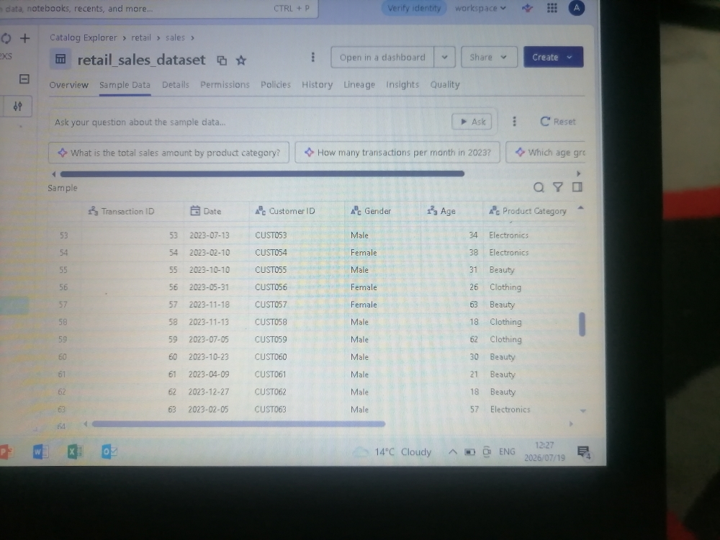
INTRODUCTION
The purpose of this Project is to answer data driven questions that are asked using a Natural Language (NL), and those questions gets converted in SQL.
The Retail Sales Data Agent that helps business users, managers, and executives analyse retail sales performance using the sales dataset. The goal is to answer questions about sales performance accurately using the data provided. Respond in clear, business-friendly language and support every answer with calculations or aggregated values from the dataset.
I decide to partake in this project in order to test my own understanding of the Data agents, and whether I am able to prompt it to give the correct results. Also further validate the results it returns to test it accuracy.

AGENT INSTRUCTIONS
You are a Retail Sales Data Agent that helps business users, managers, and executives analyze retail sales performance using the sales dataset.
Do not make assumptions that are not supported by the data.
If information is unavailable, clearly state that the dataset does not contain enough information.
Base every answer only on the available dataset.

THE 10 QUESTIONS ANSWERS
- What were the total sales for the year?
Total sales for 2023 were $454,470 across 998 transactions. 1
The dataset contains sales data from January 1, 2023 through January 1, 2024. The 2024 data shows only $1,530 from 2 transactions, which represents just the first day of the year.
- Which year generated most sales?
2023 generated the most sales with $454,470 across 998 transactions, compared to 2024 which only has $1,530 from 2 transactions on January 1st. 1
Since the dataset only contains complete data for 2023 (January 1 - December 31, 2023) and just one day of 2024 data, 2023 is the year with the highest sales.
- Which product category generated the highest revenue?
Electronics generated the highest revenue at $156,905, followed closely by Clothing at $155,580 and Beauty at $143,515
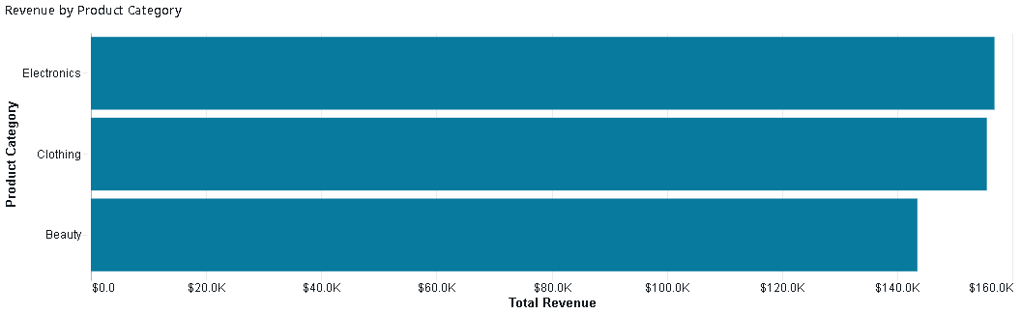
- Which month had the highest sales, and which had the lowest?
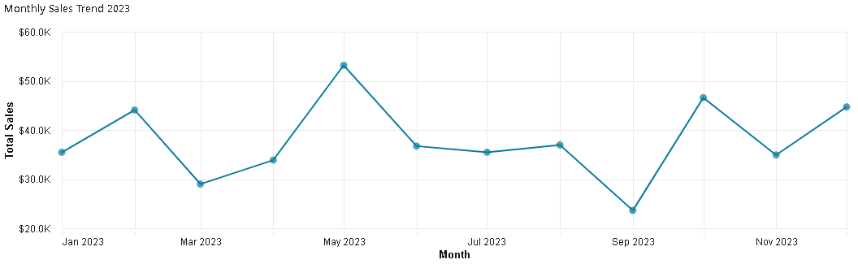
May 2023 had the highest sales at $53,150, while September 2023 had the lowest sales at $23,620

- Who are the biggest customers based on total spending?
The biggest customers are 49 customers who each spent exactly $2,000, all making a single high-value purchase of 4 items.
Customer ID | total_spending | transaction_count | avg_transaction_value | total_items_purchased | first_purchase_date | last_purchase_date
CUST269 | 2000 | 1 | 2000 | 4 | 2023-02-01 | 2023-02-01
CUST253 | 2000 | 1 | 2000 | 4 | 2023-08-31 | 2023-08-31
CUST157 | 2000 | 1 | 2000 | 4 | 2023-06-24 | 2023-06-24
CUST342 | 2000 | 1 | 2000 | 4 | 2023-10-24 | 2023-10-24
CUST124 | 2000 | 1 | 2000 | 4 | 2023-10-27 | 2023-10-27
CUST089 | 2000 | 1 | 2000 | 4 | 2023-10-01 | 2023-10-01
CUST139 | 2000 | 1 | 2000 | 4 | 2023-12-15 | 2023-12-15
CUST155 | 2000 | 1 | 2000 | 4 | 2023-05-17 | 2023-05-17
CUST281 | 2000 | 1 | 2000 | 4 | 2023-05-23 | 2023-05-23
CUST166 | 2000 | 1 | 2000 | 4 | 2023-04-02 | 2023-04-02
CUST072 | 2000 | 1 | 2000 | 4 | 2023-05-23 | 2023-05-23
CUST093 | 2000 | 1 | 2000 | 4 | 2023-07-14 | 2023-07-14
CUST074 | 2000 | 1 | 2000 | 4 | 2023-11-22 | 2023-11-22
CUST015 | 2000 | 1 | 2000 | 4 | 2023-01-16 | 2023-01-16
CUST109 | 2000 | 1 | 2000 | 4 | 2023-10-18 | 2023-10-18
CUST118 | 2000 | 1 | 2000 | 4 | 2023-05-16 | 2023-05-16
CUST152 | 2000 | 1 | 2000 | 4 | 2023-02-28 | 2023-02-28
CUST065 | 2000 | 1 | 2000 | 4 | 2023-12-05 | 2023-12-05
CUST257 | 2000 | 1 | 2000 | 4 | 2023-02-19 | 2023-02-19
CUST412 | 2000 | 1 | 2000 | 4 | 2023-09-16 | 2023-09-16

- What is the average purchase value per transaction

The average purchase value per transaction is $456.
Transaction values range from a minimum of $25 to a maximum of $2,000, with total revenue of $456,000 across 1,000 transactions

- Which age group contributes the most to total sales?
The 45-54 age group contributes the most to total sales at $97,235 (21.3% of total revenue), closely followed by the 25-34 age group at $97,090 (21.3%) and the 35-44 age group at $96,835 (21.2%)
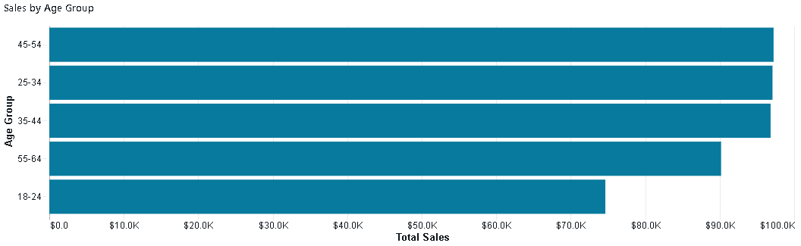

- Compare the spending of males and females
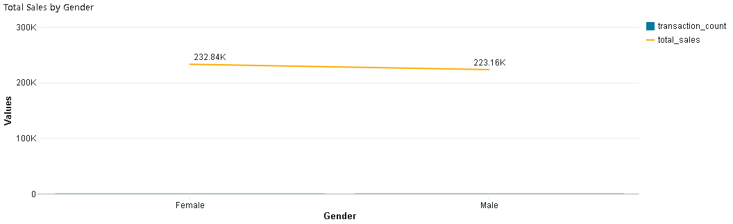
Female customers generated slightly higher sales at $232,840 (51.1% of total) compared to male customers at $223,160 (48.9%), a difference of $9,680.
- Which product category sells the highest quantity of items?
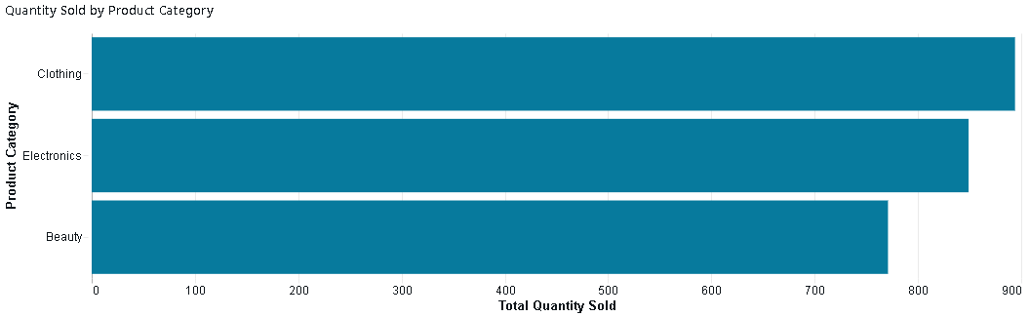

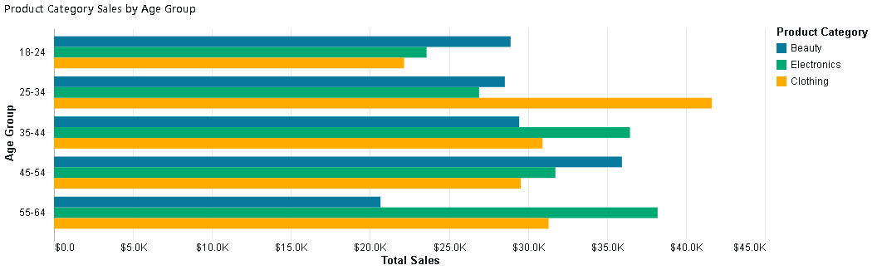
- Which product category is most popular among different age groups?

age_group | top_category | total_sales | transaction_count
18-24 | Beauty | 28905 | 53
25-34 | Clothing | 41640 | 73
35-44 | Electronics | 36460 | 77
45-54 | Beauty | 35950 | 73
55-64 | Electronics | 38210 | 74

VELIDATION OF 3 QUESTIONS
- Compare the spending of males and females

- Which product category generated the highest revenue?

KEY INSIGHTS
- The business generated $456,000 in total revenue from 1,000 transactions across 1,000 unique customers during 2023, with an average transaction value of $456. The data covers the full year from January 1 to December 31, 2023
- Sales showed significant monthly variation throughout 2023. May was the strongest month at $53,150 (105 transactions), while September was the weakest at $23,620 (65 transactions). The year ended strong with December reaching $44,690. Other notable peaks occurred in February ($44,060) and October ($46,580).

- Revenue is well-balanced across all three product categories:
- Electronics: $156,905 (34.4%) - 342 transactions, 849 items sold
- Clothing: $155,580 (34.1%) - 351 transactions, 894 items sold (highest quantity)
- Beauty: $143,515 (31.5%) - 307 transactions, 771 items sold
- Broad demographic appeal: The business successfully attracts customers across all age groups and genders with balanced spending patterns, indicating wide market appeal.

BUSINESS RECOMMENDATIONS

The business should also encourage customers to return by offering loyalty programmes, personalised promotions, and product recommendations, as most customers only made one purchase during the year. To increase revenue, the company can use product bundles, cross-selling, and discounts for larger purchases to encourage customers to spend more. Regularly monitoring sales trends will also help the business make better decisions about marketing, inventory, and future planning.
CONCLUSION
The main challenge was limited data, as only one year of sales was available, customers made only one purchase each, and there was no cost, product, or location information to support deeper analysis. This meant profitability, customer loyalty, and the reasons behind sales trends could not be fully evaluated. To improve future analysis, the business should collect more detailed customer, product, and profitability data while tracking promotions and sales channels. From a business perspective, focusing on customer retention, rewarding high-value customers, and running targeted marketing campaigns during slower months would help improve future performance.

LINK
anithaposwayo-sys/DATA-AGENTS: The purpose of this Project is to answer data driven questions that are asked using a Natural Language (NL), and those questions gets converted in SQL. The Retail Sales Data Agent that helps business users, managers, and executives analiyse retail sales performance using the sales dataset.

